Interglacial Comparisons
Posted on November 24, 2014 | 6 Comments

From http://oz4caster.wordpress.com/2014/11/24/interglacial-comparison/
Most people don’t realize that the Earth is still in a long term ice age that started about three million years ago and has had many alternating cold glacial periods interspersed with warmer interglacial periods. We are currently in an interglacial period where global temperatures have been near our modern “normal” for about 12,000 years now. In addition to our current interglacial period, there have been four previous interglacial periods in the last 500,000 years. Each one has been spaced about 100,000 years apart and lasted about 2,000 to 25,000 years with temperatures at or above our current modern “normal”. These observations are based on the EPICA Antarctic ice core climate reconstruction using oxygen isotope ratios as a proxie for global temperature change.
The graph below shows the current and last four interglacial periods plotted together, normalized to the year where the estimated global temperature first reached the level of our modern “normal” climate. The approximate year where each interglacial episode first reached the modern “normal” temperature is shown in the legend. Notice that all four previous interglacials had global temperatures reaching 2 to 4 degrees Centigrade higher than our current modern “normal” without any help from humans, based on this reconstruction.

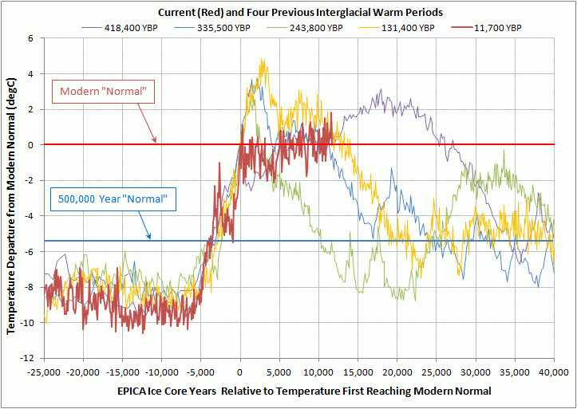
This graph compares the current interglacial period with the previous four interglacials using the EPICA ice core climate reconstruction. Each interglacial period has been normalized to the time the global temperature departure first reached the current “normal” temperature. Click on graph to enlarge.
[Presumably, the “Modern “Normal” temperature in the above chart was determined by using the red curve, from x=0 to x= now. Note that the variation of average temperature over this entire enormous timespan is only 14 ºC! -FNC ] I find it amazing how abruptly and similarly each glacial period ended in about 5,000 years to start each following interglacial warm period. In contrast, the duration of the interglacials has been much more variable. The most recent previous interglacial period that started about 130,000 years ago lasted about 14,000 years at temperatures at or above our current modern “normal”. The second previous interglacial lasted about as long as our current interglacial while the third previous was by far the shortest, lasting about 2,000 years, but arguably had somewhat of a double peak. However, the latter secondary peak did not quite reach the warmth of our current modern “normal”. The fourth previous interglacial which started about 418,000 years ago was by far the longest at about 25,000 years.
As repeatable as the glacial cycles have been over the last 500,000 years, I see little reason not to expect more of the same in the future. Using this interglacial comparison as a climate persistence forecast, we might expect about a 75% chance that the global average temperature will begin to drop dramatically sometime within the next few thousand years and about a 25% chance of staying warm for another 10,000 years or so … at most. Perhaps we need all the anthropogenic warming we can muster to stall or prevent the next glacial period?
Our understanding of what causes these glacial cycles, which are relatively recent on a geological scale, is still very limited although there are plenty of hypotheses. Our current climate models cannot predict them and therefore to me are somewhat useless. Until we can create climate models that can accurately track past glacial and interglacial periods I will not be too impressed and I certainly don’t believe our infant and untested climate models should be used to shape policy regarding “climate change”.
About these ads
This entry was posted in Climate, Climate Change, Paleo Climate and tagged climate change, global temperatures, ice age, interglacial periods, paleo climate. Bookmark thepermalink.

6 RESPONSES TO “INTERGLACIAL COMPARISONS”
- David L. Hagen | November 28, 2014 at 8:58 pm | Reply
75% chance of glaciation is a far more serious danger than a little bit of warming. On ice core Murry Salby incorporating diffusion.
See also:
By Pehr Björnbom A comparison of Gösta Pettersson’s carbon cycle model with observations
- oz4caster | November 28, 2014 at 9:50 pm | Reply
Yes, a little bit of warming may not be that bad, especially considering that during the most recent previous interglacial period evidence indicates that temperatures were high enough to raise the tree line 2,500 feet (800 m) higher than today in the mountains of Colorado. The benefits of a little warming far outweigh the detriments of another glacial period – which would (will?) be disastrous.
Colorado mastodon bones show ancient warmer Earth
- willb | November 29, 2014 at 7:14 pm | Reply
Thanks for that graph. I found it very interesting and I left a comment about it at CE.
- genghiscunn | November 29, 2014 at 11:46 pm | Reply
oz4c, far too much of the global warming debate is based on a few recent decades with little attention given to longer term data. Good to see your blog and posts at CE. Michael Cunningham, Brisbane, aka Faustino aka Genghis Cunn
- oz4caster | November 30, 2014 at 12:06 pm | Reply
Yes, maybe a bit like focusing on just one tree to describe a forest. Most forests are very diverse. We need a broader perspective, especially if we are going to be making policy about the forest

